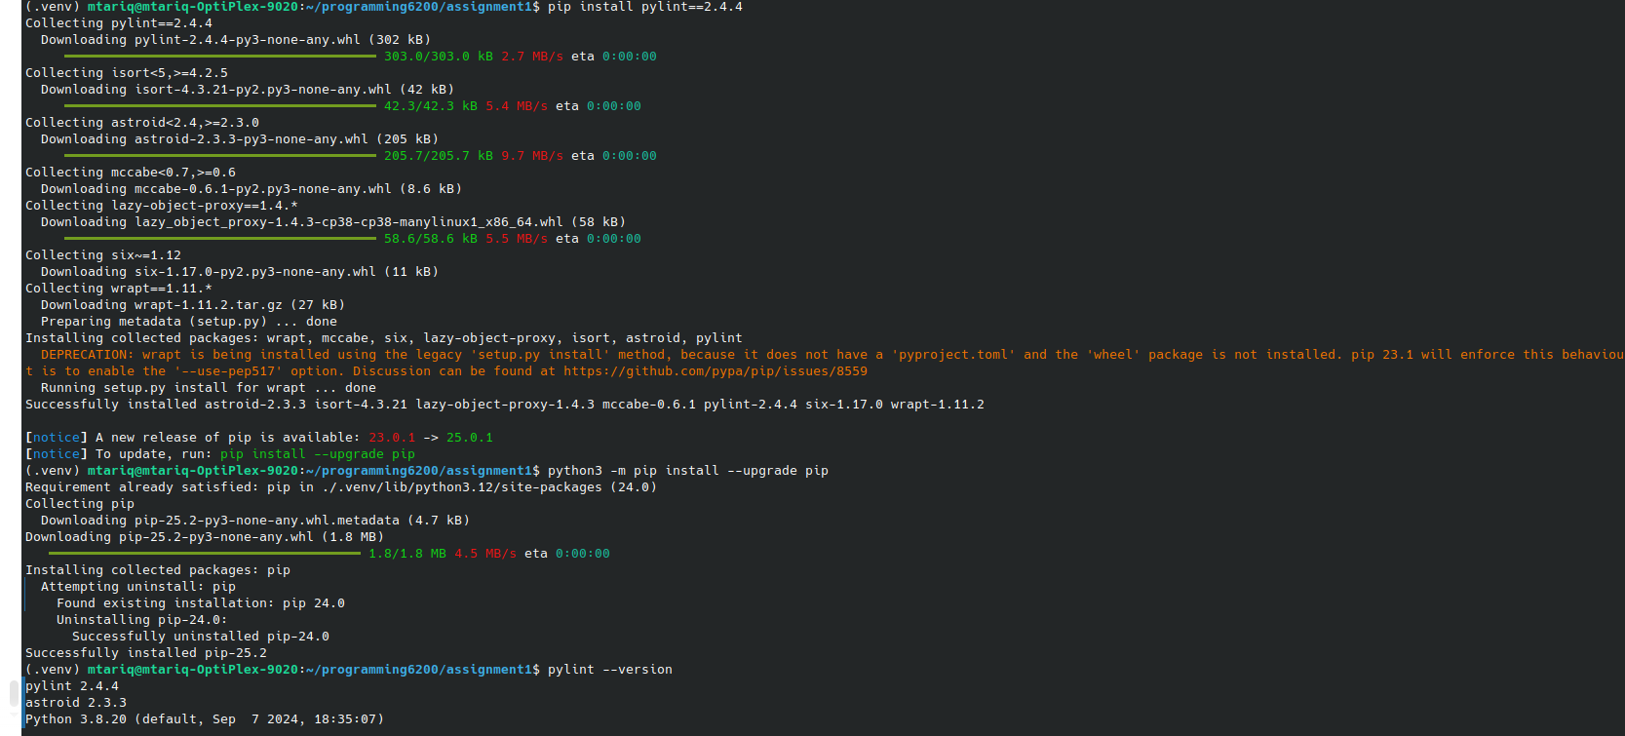
PYTHON AND PYLINT VERSION

